**Personal Learning Plan**

Delivery Date: 20th of December – 2016

Subject: Web Design – Contact page

Strengths: Enjoy coding

Weaknesses: Lack of free time

1. **SPECIFIC:**

The Contact page will follow the same basic colours (grey, black and white) It won’t have any image but only a form where the user will input name, email, subject and message. In the message box the user will be able to ask questions, give advices or criticise as well. It will require only HTML and CSS for this page.

In the image below we can see the wireframe of what needs to be achieved by the deadline been given.

1. **MEASURABLE:**

The Contact page will have 1 form with one head line, four fields with a grey border. Data type as text and a submit form button. One image as background and the form displayed in black and white.

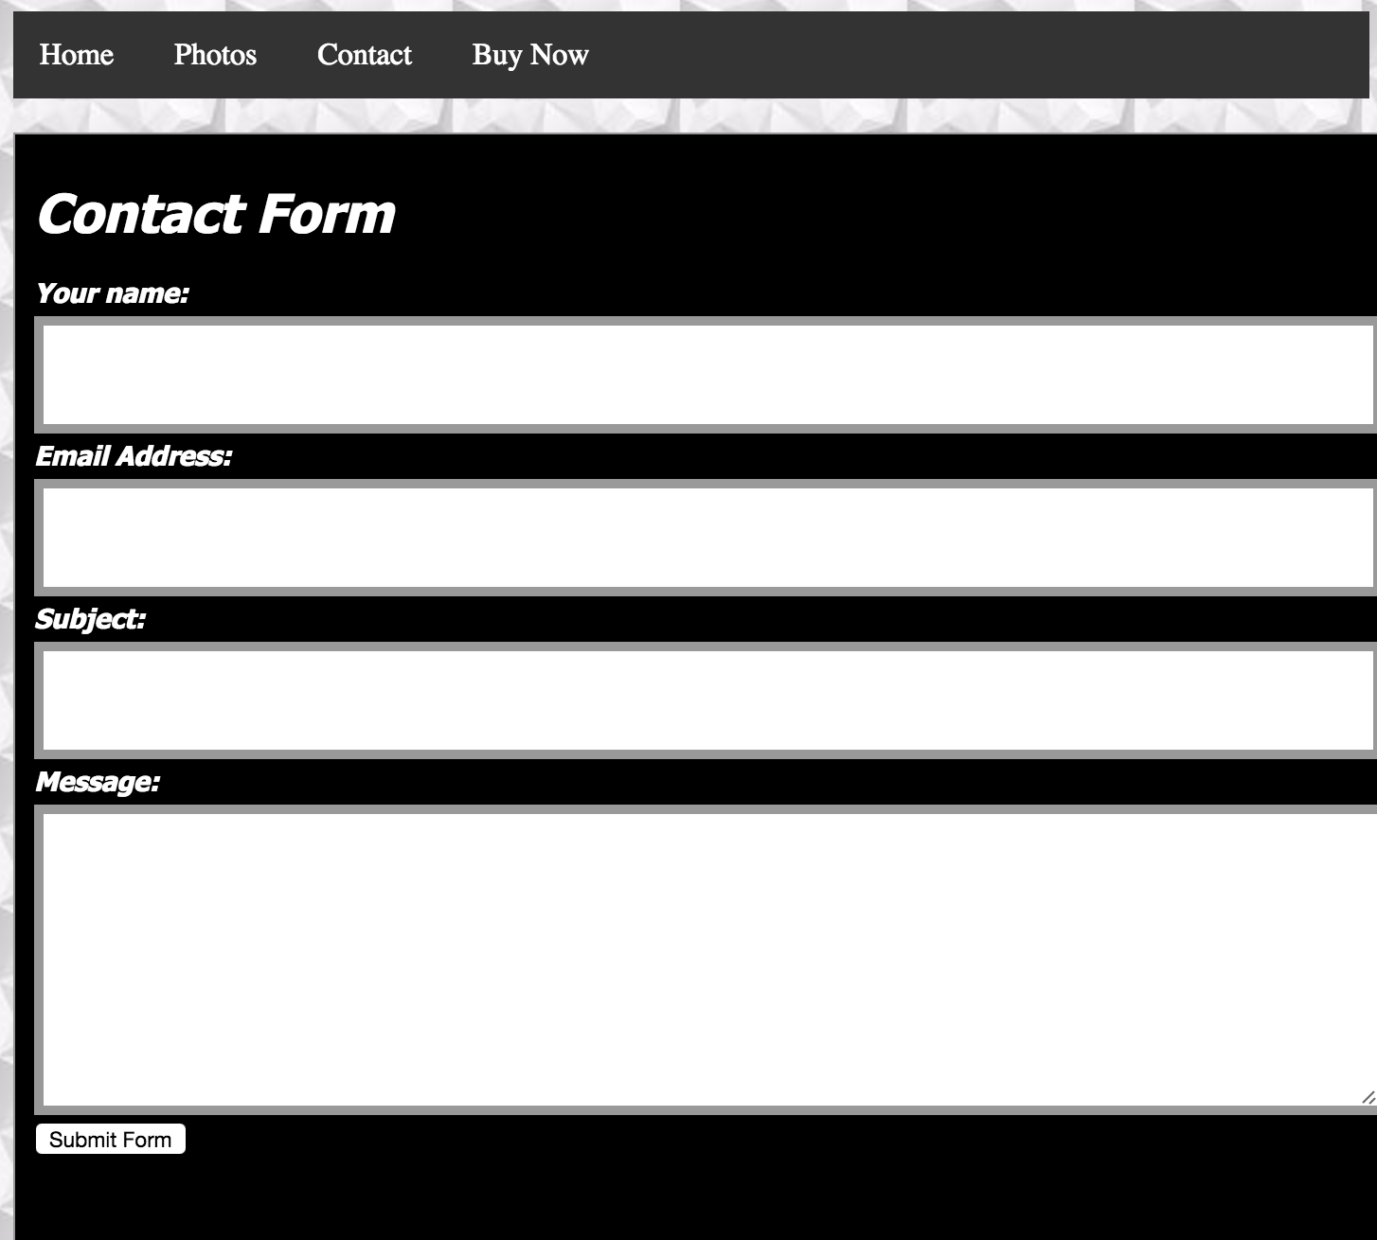

In the image above we can see the structure of it. The page will provide a channel of comunication direct with the users providing extra information.

1. **ACHIEVABLE:**

The goal is to receive feedback, improve customer service. I want to achieve at least 3 feedbacks per month.

**4. RELEVANT:**

Having users giving feedbacks is important to improve the page, the service and the business. Been in touch directly with customers is important to meet their needs.

1. **TIME-BOUND:**

Having 1 user giving feedback per month, it should take from 3 to 4 hours of work to get this built